Aim: Representation of a document with their keywords using TextRank
IDE: Google Colab

Theory:
TextRank is an algorithm based on PageRank, which often used in keyword extraction and text summarization. In this article, I will help you understand how TextRank works with a keyword extraction example and show the implementation by Python.
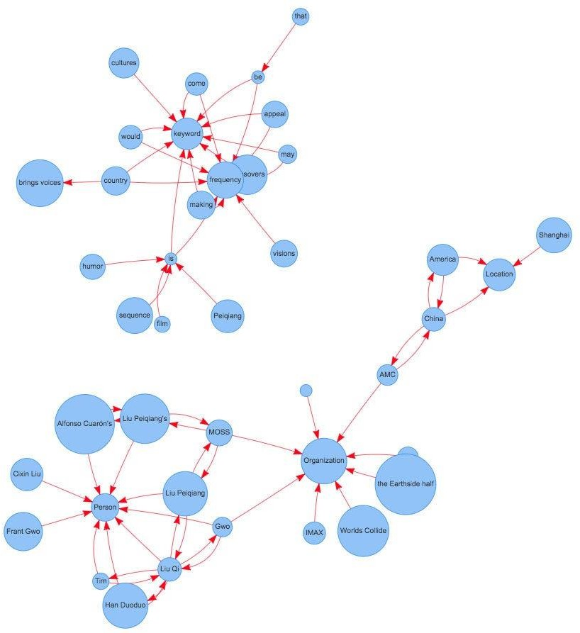
Understand PageRank

There are tons of articles talking about PageRank, so I just give a brief introduction to PageRank. This will help us understand TextRank later because it is based on PageRank. PageRank (PR) is an algorithm used to calculate the weight for web pages. We can take all web pages as a big directed graph. In this graph, a node is a webpage. If webpage A has the link to web page B, it can be represented as a directed edge from A to B. After we construct the whole graph, we can assign weights for web pages by the following formula.

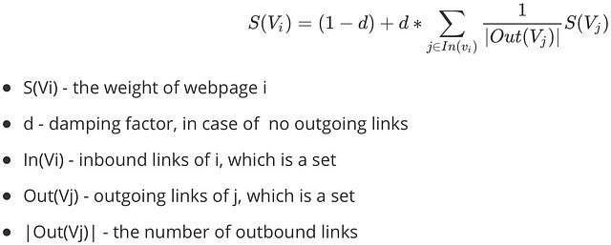
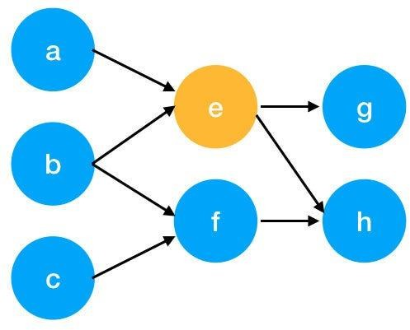

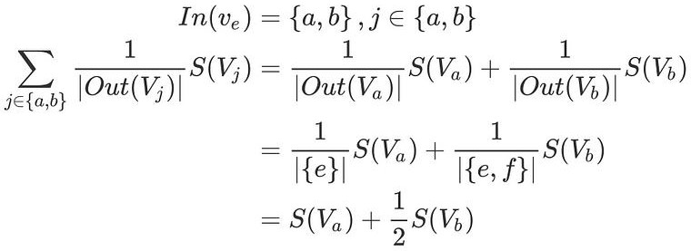
Here is an example to better understand the notation above. We have a graph to represent how web pages link to each other. Each node represents a webpage, and the arrows represent edges. We want to get the weight of webpage e. We can rewrite the summation part in the above function to a simpler version.
We can get the weight of webpage e by the following function.

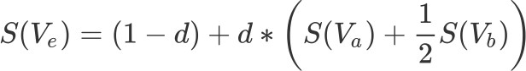

We can see the weight of the webpage e is dependent on the weights of its inbound pages. We need to run this iteration much time to get the final weight. In the initialization, the importance of each webpage is 1.

Pre Lab Exercise:

1. What are the key components of TextRank?

The key components of TextRank include text preprocessing, graph construction, and ranking algorithm. First, the text is cleaned by removing stopwords and punctuation. Then a graph is created where words or sentences are represented as nodes, and relationships between them are represented as edges. Finally, the PageRank algorithm is applied to calculate the importance score of each word or sentence, and the highest ranked ones are selected as keywords or summary.

2. What are some limitations of TextRank for keyword extraction?

TextRank does not understand the actual meaning or context of words because it is based only on word relationships. It may sometimes select less meaningful or repetitive words as keywords. The results also depend on parameters like window size, and it may not perform well for very small or highly complex texts.

3. What are the advantages of TextRank for keyword extraction?

TextRank is simple, effective, and does not require training data. It works as an unsupervised method and can be applied to any type of text. It is computationally efficient and can automatically identify important keywords based on word relationships.

Program (Code):
# Training Corpus
text = """
I like machine learning
I like deep learning
I enjoy machine learning
I enjoy data science
Machine learning is interesting
Deep learning is powerful
"""
#importing basic libraries
import nltk
import networkx as nx
from nltk.corpus import stopwords
from nltk.tokenize import word_tokenize
import string
#download requirements
nltk.download('punkt')
nltk.download('stopwords')
def textrank_keyword(text, topn=5, window_size=4):
words=word_tokenize(text.lower())
stop_words=set(stopwords.words('english'))
words=[w for w in words if w not in stop_words and
w not in string.punctuation]
graph=nx.Graph()

for i, word in enumerate(words):
for j in range(i+1, window_size+i):
if(j<len(words)):
graph.add_edge(word, words[j])
scores=nx.pagerank(graph)
ranked_words=sorted(scores.items(), key=lambda x:x[1], reverse=True)
keywords=[word for word, score in ranked_words[:topn]]
return keywords
nltk.download('punkt_tab')
print(textrank_keyword(text, topn=8))

Results:

['learning', 'machine', 'enjoy', 'deep', 'interesting', 'science', 'like', 'data']

Observation:

In this experiment, TextRank was used to extract important keywords from the given text by creating a graph of related words and applying the PageRank algorithm. Words that appeared frequently and had strong relationships with other words, such as learning, machine, and deep, received higher importance scores. The result shows that TextRank effectively identifies key terms from text without using training data.
Post Lab Exercise:
- Write about “your ownself” (in not more than 500 words→ You know better about you, rather than ChatGPT!!). Extract top-25 keywords for your portfolio and analyze it in 3 categories: keyword can not give the real idea, keyword gives the real idea, keyword is irrelevant. Paste the code, your portfolio, output and your analysis.

Code:
import re
from collections import Counter

text = """
I am a curious and hardworking Information and Communication Technology student who enjoys solving real-world problems using technology.
I believe learning should be practical and meaningful.
I have worked on projects that combine hardware and software, which helped me understand how different technologies interact with each other. One of my projects involved designing an RFID-based barrier system that allows only authorized users to access a restricted area. This project strengthened my understanding of sensors, authentication, and system integration.
Worked on IoT-based safety system and smart elevator using machine learning and sensors.
Learned Python programming, data analysis, and microcontroller interfacing.
I used to be interested in frontend development including HTML, CSS, JavaScript and jQuery, but now i am more interested towards embedded systems and VLSI.
Disciplined person balancing academics, health and growth.
Currently I am building strong foundation in digital electronics, communication systems and probability.
Goal is to contribute to innovative technologies and efficient systems.
"""

# preprocessing
words = re.findall(r'\b[a-zA-Z]+\b', text.lower())

# remove common stopwords
stopwords = {"and","the","is","in","on","a","an","to","for","of","i","am","be","using","with","like"}
filtered_words = [w for w in words if w not in stopwords]

# count frequency
word_freq = Counter(filtered_words)

# get top 25 keywords
top_keywords = word_freq.most_common(25)

print(top_keywords)

Result:
[('system', 3), ('systems', 3), ('communication', 2), ('technology', 2), ('learning', 2), ('worked', 2), ('projects', 2), ('that', 2), ('technologies', 2), ('my', 2), ('based', 2), ('sensors', 2), ('interested', 2), ('curious', 1), ('hardworking', 1), ('information', 1), ('student', 1), ('who', 1), ('enjoys', 1), ('solving', 1), ('real', 1), ('world', 1), ('problems', 1), ('believe', 1), ('should', 1)]

